COMP 9900 Information Technology project 2023 T2

Retrospective A

Assessment

Group: 9900F15APT5D

**Yue Niu (Scrum Master)**

Front-end/Back-end z5356976 z5356976@ad.unsw.edu.au

**Haoxian Zhang**

Back-end z5327309 z5327309@ad.unsw.edu.au

**Lichen Zhang**

Front-end z5373704 z5373704@ad.unsw.edu.au

**Zhourui Shi**

Front-end z5348712 z5348712@ad.unsw.edu.au

**Yimin Liu**

Back-end z5228038 z5228038@ad.unsw.edu.au

30 June 2023

Contents

Retrospective A group meeting 2

Section 1: What went well 2

Section 2: What did not go so well 3

Section 3: What things to try in the next sprint to improve the team’s work process 4

**Plan** 4

**To try list for the member who attempting to enforce or follow up on each item:** 5

# Retrospective A group meeting

Meeting Date: 30/06/2023

Meeting Time: 17:00 PM

Submission Date: 01/07/2023, 11:20 AM

Attendees: All team members are present at the Retrospective A meeting.

# Section 1: What went well

In this section, firstly we have finished our 17 user story in sprint 1 as shown below in Figure 1.

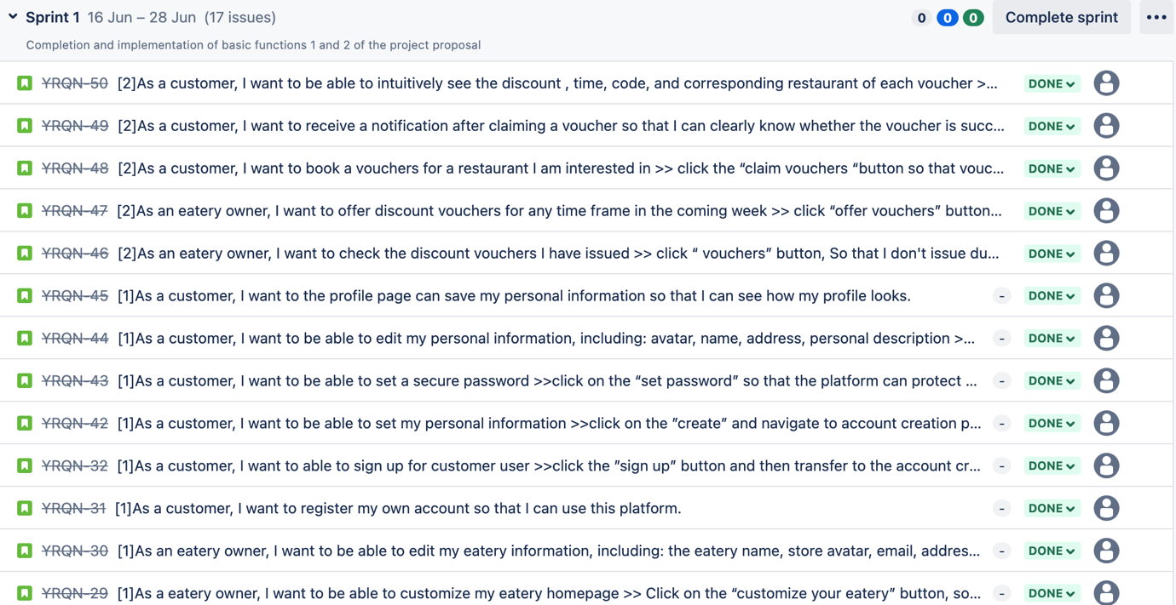

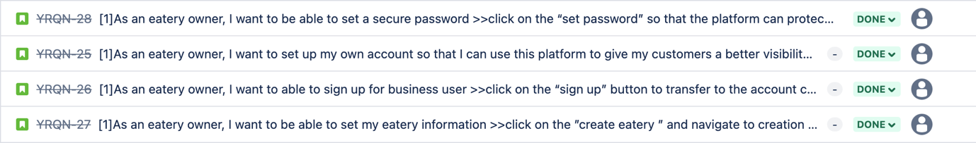

*Figure 1 User stories of sprint 1 in Jira.*

Our project is about Restaurant Management System. In the function implementation of demo, A this week, our goal is to set up customer and Eatery for login, personal information settings, how Eatery can manage and issue the vouchers, and how customers receive and check the vouchers on their page. We provide Eatery and customers with the freedom to simultaneously design their personal information, including uploading avatars, personal descriptions, etc.

* 1. During the voucher setup phase

From the Eatery's point of view, we provide full and detailed information to help. For example, after the Eatery opens the voucher distribution management page, he only needs to set the discount amount and validity period in the fixed box.

From the customer's point of view, customers can find the reservation voucher button on the homepage of each restaurant, and after clicking it, they will automatically jump to the reservation voucher page, which will display the specific content of each voucher in detail, so that customers can choose by themselves to book vouchers. After the reservation is successful, the customer will receive a message that the reservation is successful and can check the number of vouchers they received and the specific discount information in the personal settings.

Our database design is characterized by its convenience, no redundancy, no waste of memory, and quick addition, deletion, query and modification.

The front-end framework is relatively clear, the branch of each function is clear and the code is not streamlined.

API-Managing the eatery and customer user classes using the blueprint module to ensure clear and concise code for easy management and future development.

# Section 2: What did not go so well

2.1. The front end and back end are not fully connected, such as the profile page.

2.2. Our function is not connected to Jira.

2.3. Did not prepare according to the rules of demoA.

# Section 3: What things to try in the next sprint to improve the team’s work process

The things we want to try on sprint 2 show below in Figure 2.

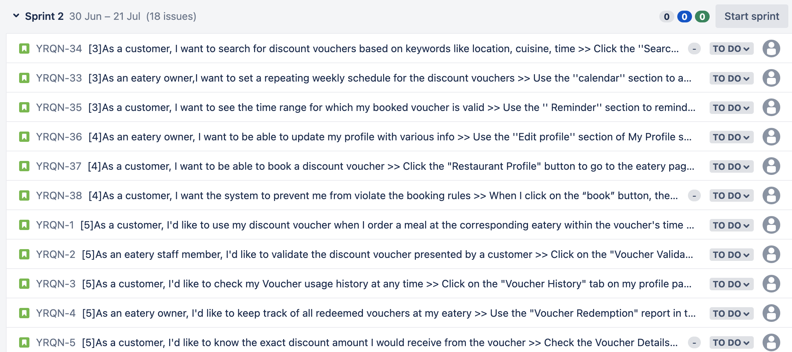

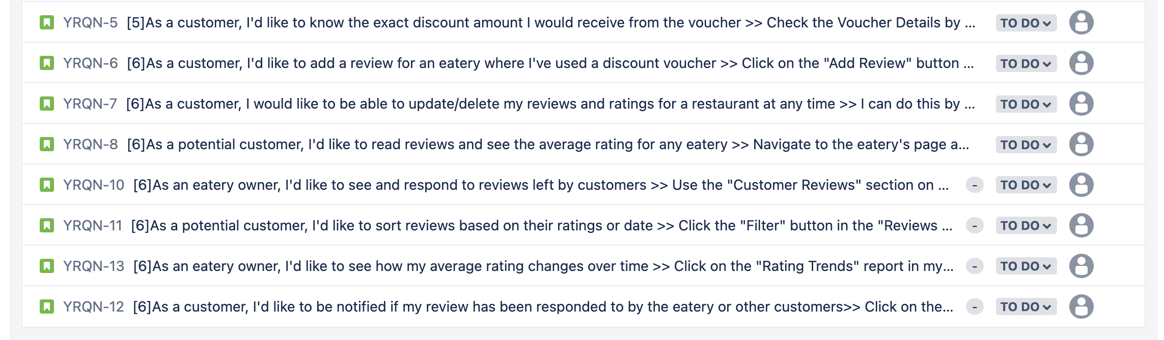

*Figure 2 User stories of sprint 2 in Jira.*

## **Plan**

Our sprit2 are still in progress, so we first assign the 18 user stories in our sprint2 to team members, then subdivide and plan the user stories according to the next four functions and upload them to Jira on time.

User story: YQRN 33-38 Yue Niu.

User story: YQRN 1-4 Zhourui Shi

User story: YQRN 5-7 Licheng Zhang

User story: YQRN 8-10 Yiming Liu

User story: YQRN 11-12 Haoxian Zhang

## **To try list for the member who attempting to enforce or follow up on each item:**

*Table 1. To try list*

|  |  |
| --- | --- |
| Item | Assigned member |
| Check and run the front-end and back-end codes, communicate and solve problems in a timely manner. | Haoxian Zhang |
| Determine when each project starts and finishes. Communicate in a timely manner during the completion of the project to ensure that the project will not be delayed. | Yue Niu |
| Overall visual design of the project | Zhourui Shi |